Our Biswas
Our Belief In Services for Women of All Societies
1210 Whittier Drive, East Lansing, MI 48823
Ourbiswas9@gmail.com
Registered No. 70155X, EIN 87-0811973

Board of Directors
President
Joyasree Mahanti
Vice President
Christine Hartmann
Secretary
Sally Pratt
Treasurer
Malti Agrwal
Directors
Aparna Agrawal
Shakti Kaul
Batool Mir
Sharon Monsma
Margo Smith

August 24, 2012
Friends,
Aamara Biswas has started the training/production center in Kiakata village of Anugul district of Odisha, India in December, 2011 with your support through Our Biswas.

Our Biswas is delighted to sponsor another potluck dinner on Friday, September 21, 2012@ 6:30 for raising funds for buying materials for making garments and to support the teacher’s salaries for the coming year. Our Biswas needs $1500 to cover both the expenses. The dinner will be at 1210 Whittier Drive, East Lansing, MI 48823.
Each participant will contribute $15 or more towards the dinner. Please see the details in the next page. Your contribution is tax deductable. Thank you for your support.

Sincerely,

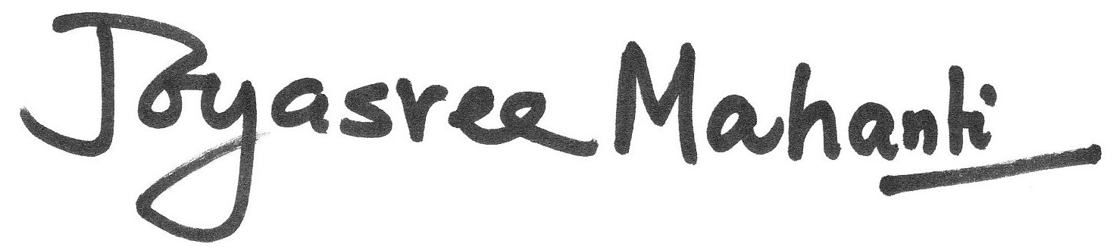
Joyasree (Ranu) Mahanti
(517)337-9570
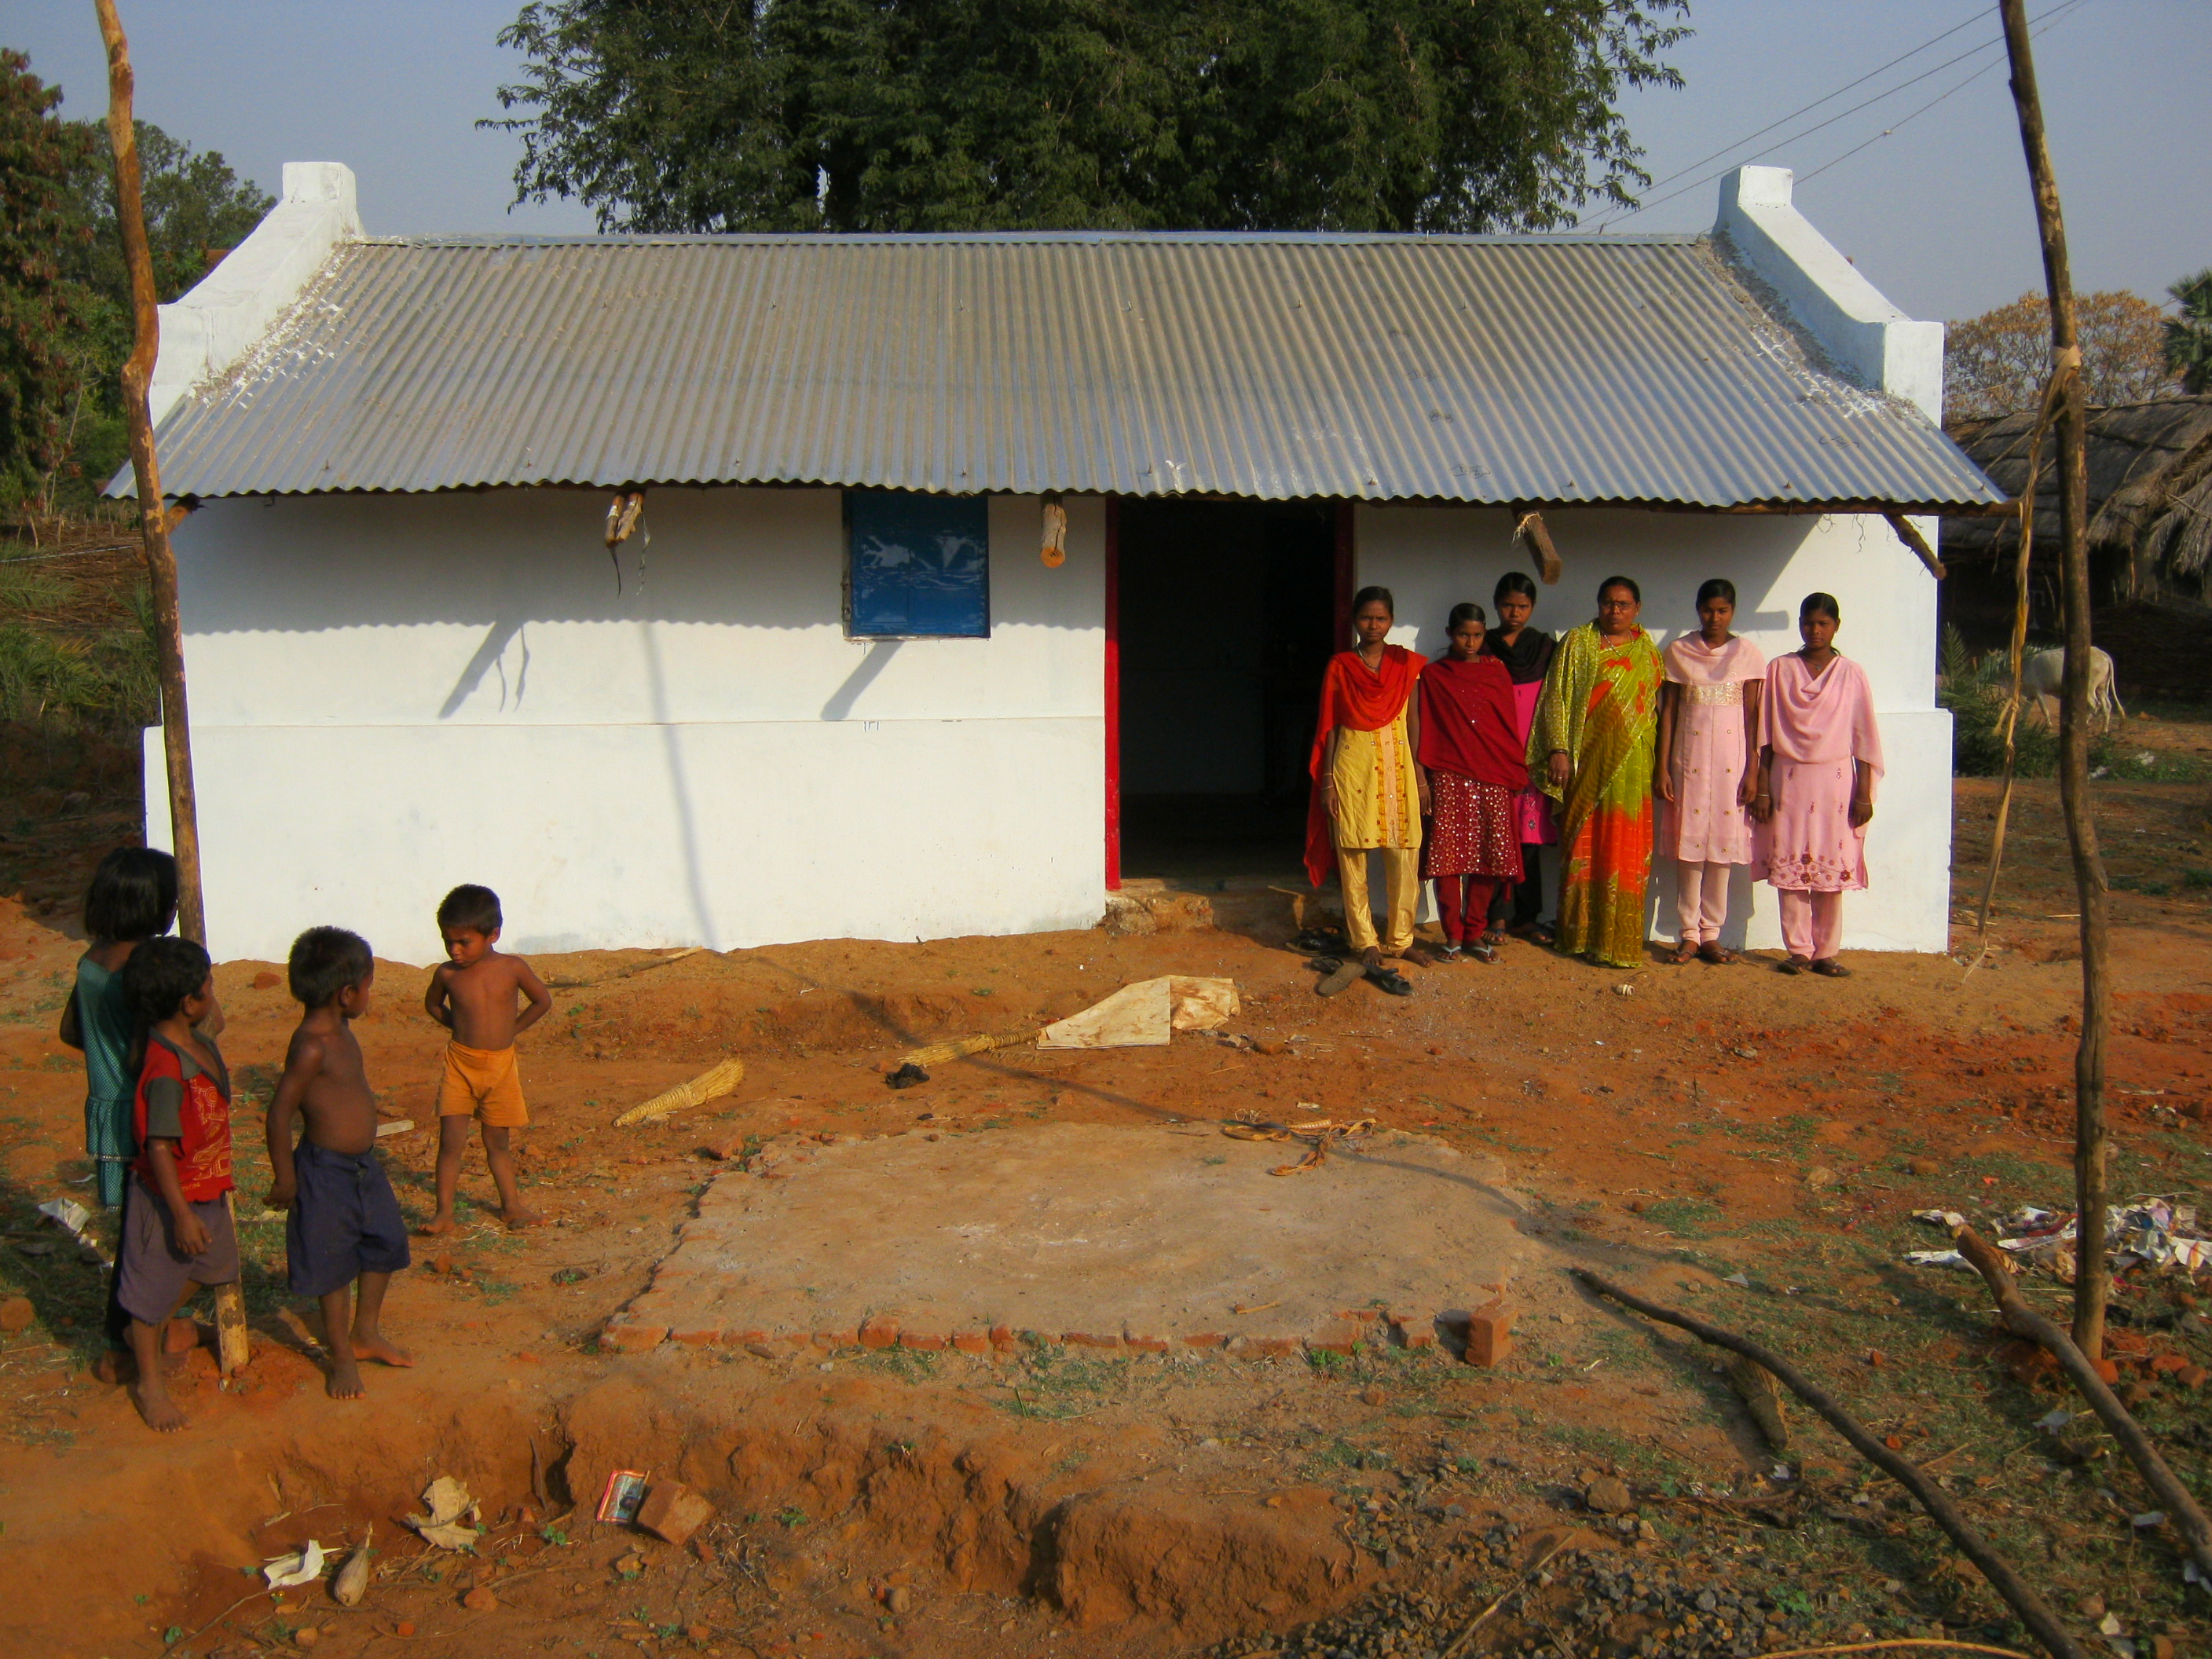

The above picture is the training center which is only possible with your contribution.

